GoFundMe
GoFundMe is a website that was created in 2010 to benefit people in need. People create campaigns to persuade people to donate to their cause. The campaigns include stories of the person in need and their family as well as the end goal that they would like to reach. The website utilizes the three rhetorical devices of logos (logic), ethos (credibility), and pathos (emotions), but it does not use them equally. When persuading people to donate, emotion is the most effect way of going about persuading someone to donate to a cause. Because of this, pathos is the number one used rhetorical device, ethos coming next because people must know that they are donating to an ethical and credible source. Logos seems to be hardest rhetorical device to describe from this website, so it will be ranked third out of three of the most used.
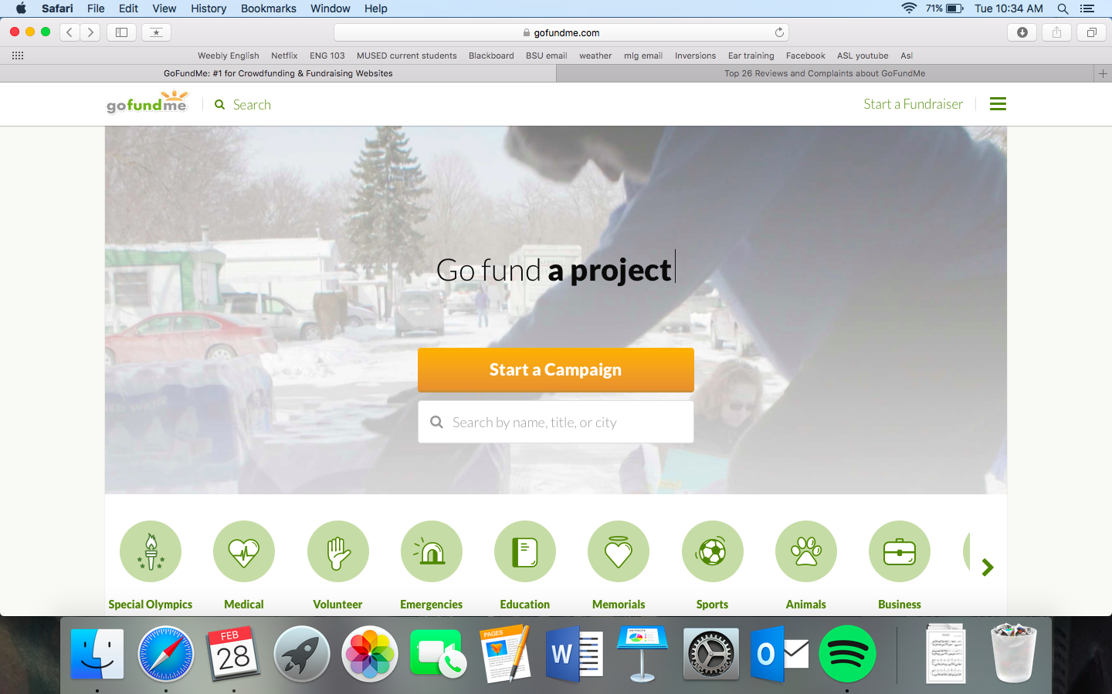
Looking at the website before the reader even scrolls down to view the different stories and campaigns posted, the reader is greeted by colors of pale green and light orange accompanied by a scrolling screen that says, “Go fund a family. Go fund a pet” and so on with happy pictures depicting what happens when people fund these campaigns (pictured on the next page). The overall theme of the website is playing into the emotions that the readers will feel when they open the page. The colors make the site very positive and uplifting to look at. The colors of green and light orange that were chosen complement each other well and bring ideas of cheer and joy into the minds of the readers. Color Wheel Pro describes green as one of the most pleasing colors to look at by because it is associated with natural feelings such as growth and harmony. Light orange evokes emotions such as happiness, encouragement, and success. The colors are chosen to create a positive environment for the people reading the campaigns and the people creating them. The web-designers would not have wanted to pick harsh colors like red or black to evoke emotions of happiness. According to Color Wheel Pro, red is related to anger and hatred; black is associated with fear and mystery. These would not have been the colors to choose for an encouraging website like GoFundMe. A lot of the people who are creating campaigns are going through tough times and the website needs to seem encouraging to them so that they feel less anxious and more confident that their lives are going to fall into place and that people will be willing to help them in their time of need.
Emotional appeals are almost always a good way to persuade someone to do something. GoFundMe creators and the people who create campaigns know this. The website tugs at peoples’ heart strings when they see the pictures and stories uploaded: “Tufte Family Funeral Expenses” (picture of 3 children, now deceased), “Devin Needs Your Help!!!” (with a happy child as the cover photo).
Pictures are a huge part in creating campaigns on the website. All the stories on the front page, which is set up in a news feed layout, have a cover photo and a title of who and what the money will go to. Some stories incorporate not only a cover photo but pictures throughout the story; if the campaign is funding a sick child perhaps there is a picture of them when they are healthy before the diagnosis and then a picture of them in the hospital bed recovering from surgery. The stories of these people are very moving but when a photo is added and the reader can see the person and make a connection to them want to help them even more than they did by just reading the story. These photos of people in need break readers’ hearts and persuade them to donate to the cause because they feel bad for the parents who lost all three of their children in a fire or little Devin who is only a kid and is dealing with cancer. Making people emotional is what these kinds of stories do best because it is heartbreaking to think of oneself being in these situations; imagining what the families are going through makes it easy to want to donate and make their lives a little bit better.
Credibility is well established with this website because almost all that the website does is format. The stories are written by the people who are affected by the stories; the people can provide contact information if they choose to do so, this way the readers know where the story came from and are not concerned with it being a scam to donate money to a cause that is not real. Because the website monitors fraudulent campaigns being started, the readers can be sure that the campaigns that they donate to are real causes and real people in need. The people who create campaigns on GoFundMe want to know that they can share their story on multiple platforms; GoFundMe campaigns can share stories on Facebook and Twitter. Donors can also contact the people who started the campaign if they choose to provide information. This makes the stories much more personal when the donors know they can talk to the people who they are giving the money to. That alone makes GoFundMe more credible because they need not worry if the stories are real or not because if they question the reality of the page, then the donors can contact the people directly as well as file a claim on the GoFundMe website. Having multiple methods of communication with the donors and campaigners is a very good thing for GoFundMe.
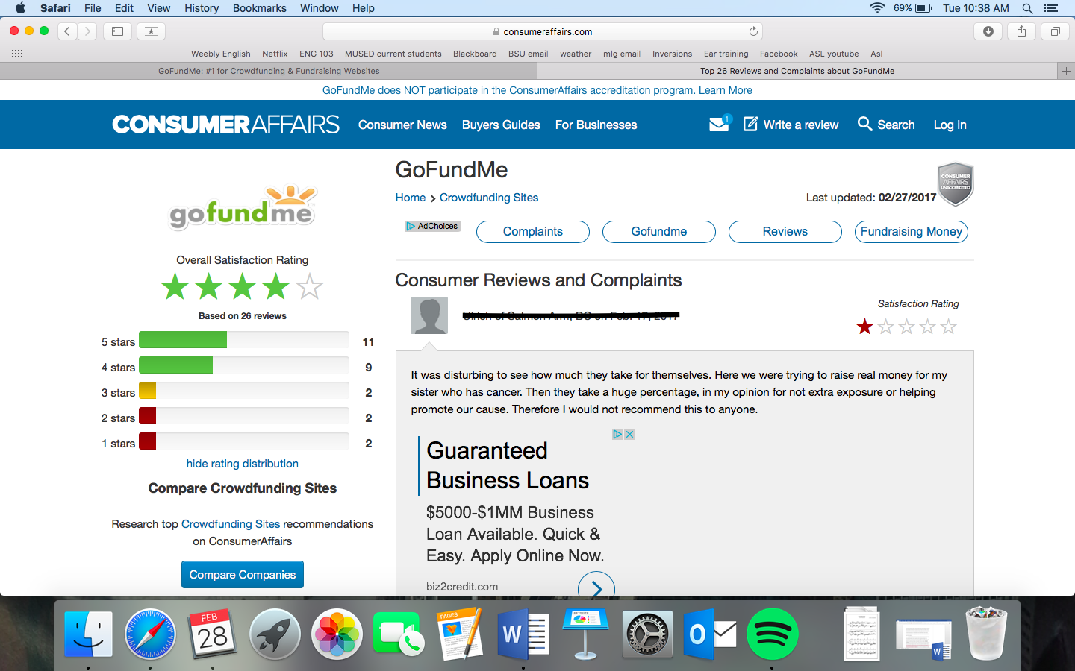
GoFundMe in itself is a logical thing to make. A website that is made solely for helping people through tough times could never be bad thing. The creators of the website could have done only one thing differently and that would be to not charge people per donation. GoFundMe charges each donation 5% so if someone donates $100 GoFundMe gets $5 of that. Some of its donors and users are not so happy about this but it does not seem to have stopped people from making it a very popular site to use for crowdfunding. Even though GoFundMe does collect 5% of the donation, the families still receive the majority of the money, and they would not have received any had they not signed up for a GoFundMe campaign. The website has to make a profit and that is logical; it is not going to build itself. Having the ability to share the stories on the website on social media is also appealing to logic. If a donor feels so compelled to donate, they might want to share the story with people they know and then persuade more people to donate to the cause that they thought was worthy. Sharing stories is a very useful tool on the website and can make the website appeal to more people because they have the ability to share the story on more platforms than just the website and its viewers.
All in all, GoFundMe uses the rhetorical devices of ethos, logos and pathos in many ways throughout their website. The color scheme appeals to pathos, as do all of the tear-jerking stories that are posted to the website. The appeal to logos is harder to find than the appeals to pathos is, but the fact that they charge money for transaction fees does make sense, even if some users do not agree with the logic. Ethos is appealed to through the formatting of the website because the stories are true and not written by the company to make a profit; the ability to share stories on social media and to platforms other than just GoFundMe is also a great appeal to logic because if people felt so compelled to donate they would want to share the story to help that family out even more. GoFundMe does what it is supposed to do, and that is to raise money and persuade people to give money to people in need.

